# Introduction

## Overview

The Smart Assignment Website is a comprehensive web-based application designed to simplify assignment management and foster collaboration among students, teachers, and administrators. The project utilizes a Flask backend framework, IBM DB2 for database management, IBM COS for storage, and HTML/CSS for frontend design.

The primary objective of the Smart Assignment project is to create an intelligent platform that automates various aspects of the assignment process. This includes assignment creation, submission, grading, and feedback. By leveraging web development technologies, the project aims to enhance the efficiency and effectiveness of handling assignments.

Students have the ability to access the platform to view their assignments and submit completed work securely. The system incorporates features such as secure file uploads, ensuring the confidentiality and integrity of submitted assignments. Moreover, the application provides timely notifications and reminders to students about upcoming assignment due dates, as well as any updates or clarifications from their teachers.

The Smart Assignment platform not only streamlines administrative tasks related to assignments but also strengthens communication between students and teachers. Through its user-friendly interface and intelligent features, the application facilitates a more engaging and efficient learning experience. By leveraging technology, Smart Assignment aims to improve educational outcomes, promote collaboration, and elevate the assignment management process to new heights.

## Purpose

The Smart Assignment Website project serves as a comprehensive web-based solution aimed at optimizing assignment management and fostering collaboration among students, teachers, and administrators within educational institutions. This endeavour harnesses the capabilities of a Flask backend framework, IBM DB2 for database management, IBM COS for storage, and HTML/CSS for frontend design.

Within the framework of this project, well-defined user roles have been established:

Administrators, as the key initiators, hold the pivotal responsibility of creating user accounts. This role ensures controlled access to the platform, fostering a secure environment for all stakeholders.

Teachers, as significant contributors, are empowered with the exclusive ability to generate assignments, seamlessly distribute them to students, and undertake the assessment process. The platform streamlines and automates assignment-related workflows, eliminating the need for manual interventions and paperwork.

Students, benefiting from the platform, can securely access assigned tasks, submit their completed assignments, and receive timely notifications. The project places a strong emphasis on secure file uploads, ensuring the confidentiality and integrity of submitted work.

Notable achievements include streamlined administrative functions, heightened support for remote learning, and a commitment to sustainable practices by reducing paper consumption. By amalgamating technology with role-specific features, the Smart Assignment project endeavours to revolutionize assignment management, cultivate collaborative interactions, and enrich the overarching educational journey.

# Litrature Survey

## Existing problem

In the context of education, the conventional methods of managing assignments often involve manual processes, resulting in challenges such as delayed feedback, misplaced assignments, and ineffective communication. The shift towards remote learning has underscored the importance of digital solutions that can efficiently handle assignment management and enhance collaboration.

Various approaches have been explored to address these challenges:

**Learning Management Systems (LMS):** LMS platforms like Moodle, Blackboard, and Canvas have gained popularity for managing assignments. They provide features for creating, submitting, and grading assignments in a digital environment. However, they might lack the advanced automation required for a more streamlined process.

**Online Assignment Platforms:** Platforms such as Turnitin primarily focus on detecting plagiarism and ensuring originality. While they address a specific aspect of assignments, they might not cover the complete assignment management lifecycle.

**Custom Web Applications:** Certain educational institutions develop tailor-made web applications to manage assignments. While this approach offers customization, it can demand significant development effort and ongoing maintenance.

**Email and File Sharing:** Some educators resort to distributing and collecting assignments through email. However, this decentralized approach lacks automation and can result in errors and delays.

**Peer Assessment Tools:** Peer assessment tools allow students to evaluate each other's work, promoting collaborative learning. However, they might not fully replace the need for teacher involvement in grading.

**Integrated Solutions:** Several learning platforms integrate assignment management into a suite of educational tools. These platforms offer functionalities like discussion forums, content sharing, and assignment tracking.

**Cloud Storage and Collaboration Tools:** Cloud storage services (e.g., Google Drive, Dropbox) and collaboration tools (e.g., Microsoft Teams, Slack) facilitate file sharing and communication. However, they lack specialized features for assignment management.

## Proposed Solution:

The Smart Assignment Website project introduces a comprehensive solution to address the challenges faced in traditional assignment management within educational settings. The proposed method encompasses the following key elements:

The project leverages modern technologies, including Flask for backend development, IBM DB2 for efficient database management, IBM COS for secure storage, and HTML/CSS for creating an intuitive frontend interface.

**Role-Based Access:** The platform implements distinct roles for administrators, teachers, and students. Administrators are exclusively responsible for creating user accounts, ensuring controlled access. Teachers possess the authority to create assignments and evaluate student submissions. Students, on the other hand, have access to assignment details and the capability to submit their completed work securely.

**Assignment Lifecycle Management:** Teachers can conveniently create assignments using the platform, including specifying relevant details and submission deadlines. The platform provides the flexibility to distribute assignments to specific students or groups, ensuring targeted communication.

**Efficient Assignment Submission:** Students are empowered to securely upload their completed assignments through the platform. This eliminates the need for physical submissions and minimizes the risk of document loss.

**Effective Communication:** The platform acts as a hub for communication between teachers and students. Teachers can convey updates, clarifications, and announcements related to assignments, while students can seek guidance or ask questions as needed.

**Timely Notifications:** The system sends notifications to students about upcoming assignment due dates, ensuring that students can manage their time effectively and submit assignments punctually.

**Centralized Task Management:** Students benefit from a centralized platform that displays assigned tasks, submission deadlines, and relevant assignment details. This aids in organization and planning.

**User-Friendly Interface:** The platform boasts a user-friendly interface that facilitates effortless navigation and interaction for all users, promoting an intuitive experience.

# Theoretical Analysis

## Block Diagram

## Hardware & Software Design

In the hardware and software designing aspect of the Smart Assignment Website project, careful consideration has been given to ensuring the project's functionality, performance, and user experience. Both hardware and software components play a pivotal role in achieving the project's objectives.

Hardware Requirements: The hardware requirements for the project are relatively modest due to the web-based nature of the application. A standard web server infrastructure is required to host the application. This includes a server with sufficient processing power and memory to handle incoming requests and process database operations efficiently. Additionally, the server should have reliable network connectivity to ensure smooth communication between users and the application. The use of cloud-based hosting services can also be considered to provide scalability and reliability.

Software Requirements: The software components of the Smart Assignment Website project consist of both the backend and frontend technologies.

For the backend, the project employs the Flask framework. Flask is a lightweight and flexible Python web framework that provides the necessary tools for building web applications. It is utilized to handle user authentication, manage database interactions using IBM DB2, and support the core functionality of the application, such as assignment creation, submission, grading, and communication.

On the frontend, HTML and CSS are used to design the user interface. HTML is employed to structure the content of the platform, while CSS is used for styling, layout, and presentation. These technologies collectively create an intuitive and visually appealing interface that facilitates user interaction and engagement.

The integration of IBM COS for storage purposes enhances data security and reliability. This cloud-based storage solution is used to securely store uploaded assignment files and other relevant data. Its seamless integration with the platform ensures the integrity of user-submitted work.

# Experimental Investigations

During the development and implementation of the Smart Assignment Website project, several experimental investigations were conducted to ensure the effectiveness, reliability, and user-friendliness of the solution. These investigations focused on different aspects of the platform's functionality and user interaction.

**User Testing and Feedback:** One of the primary experimental approaches was user testing, involving students, teachers, and administrators. A diverse group of users interacted with the platform to perform tasks such as assignment creation, submission, grading, and communication. Their feedback and observations were collected to identify usability issues, interface glitches, and any challenges they encountered. This iterative feedback process played a vital role in refining the user experience and making necessary adjustments to the platform's design.

**Performance Testing:** Performance testing was carried out to assess the system's responsiveness and scalability. Simulated user loads were applied to the platform to evaluate its performance under different levels of activity. This investigation aimed to identify potential bottlenecks, optimize database queries, and ensure that the application could handle a substantial number of concurrent users without degradation in performance.

**Security Evaluation:** Security was a paramount concern, and thorough security evaluations were conducted to identify vulnerabilities and potential risks. Penetration testing was employed to simulate malicious attacks and assess the platform's resistance to breaches. Measures were taken to ensure secure data transmission, prevent unauthorized access, and safeguard sensitive information.

**Compatibility Testing:** Compatibility across different devices and browsers was a critical aspect. The platform was tested on various devices, including desktops, laptops, tablets, and smartphones, using different web browsers. This ensured a consistent and user-friendly experience regardless of the device used to access the platform.

**Data Integrity and Storage Testing:** Experiments were conducted to ensure the proper functioning of the file upload and storage mechanisms using IBM COS. Data integrity checks were performed to confirm that files were uploaded and stored accurately, without corruption or loss.

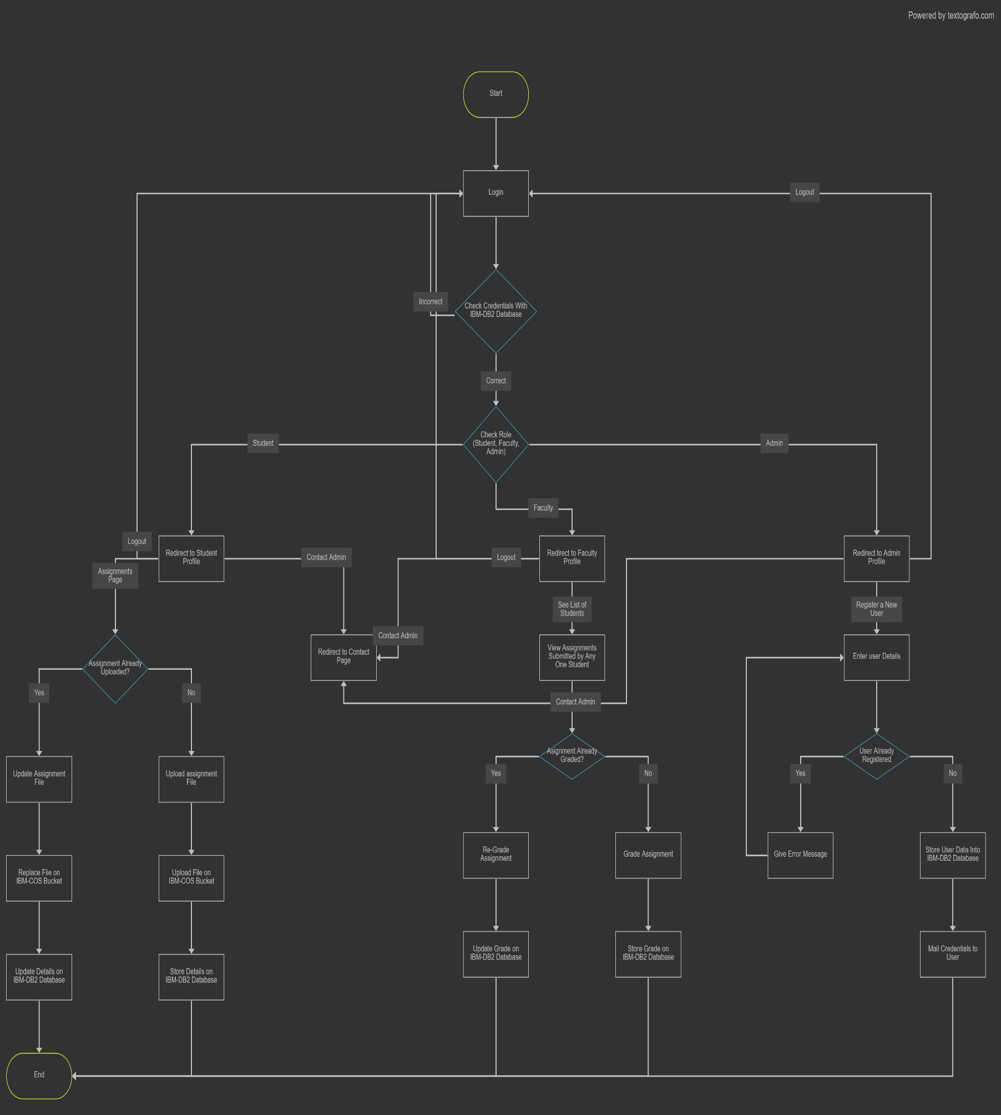

# [Contact Page](https://user-images.githubusercontent.com/131831457/260325532-651db3e7-05db-4276-846b-20bdbb174fb7.png)Result

[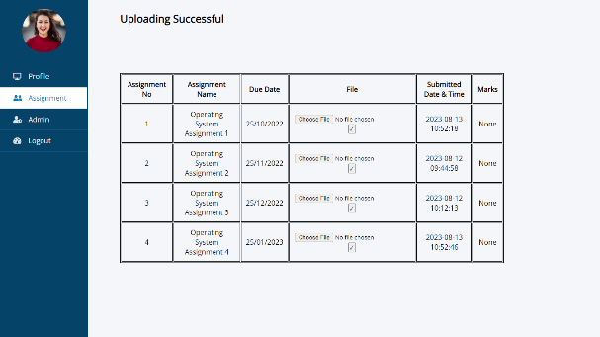](https://user-images.githubusercontent.com/131831457/260325553-a0c1e436-9743-4bf0-9842-0a2b24c277f6.png)[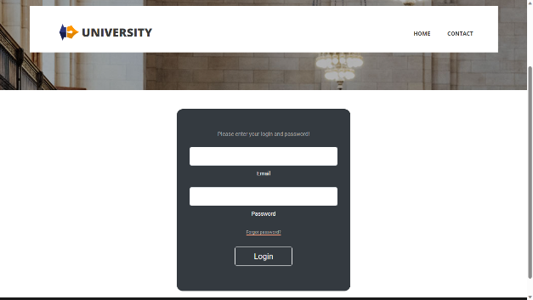](https://user-images.githubusercontent.com/131831457/260325540-8340c5a6-27b9-45cf-96c6-96b6bd0c5d3c.png)[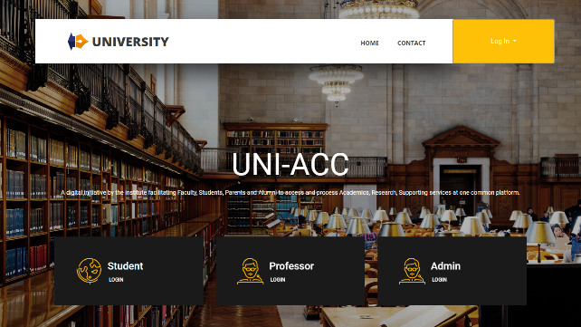](https://user-images.githubusercontent.com/131831457/260325514-9bf3ad80-d153-4dba-9122-9db91cc43d7c.png)

[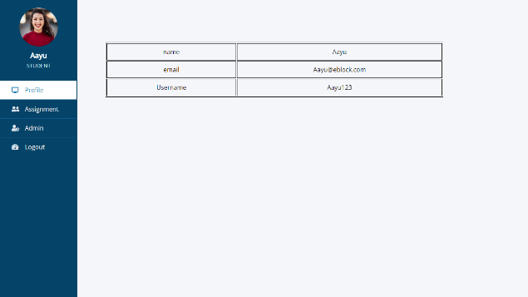](https://user-images.githubusercontent.com/131831457/260325544-4d8159e1-4c4e-41e0-a3e0-336d73294668.png)[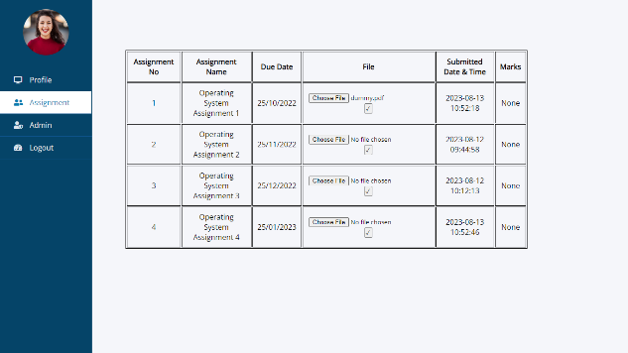](https://user-images.githubusercontent.com/131831457/260325546-ec86066a-3f22-4f05-bca8-9f4e66fd9776.png)

[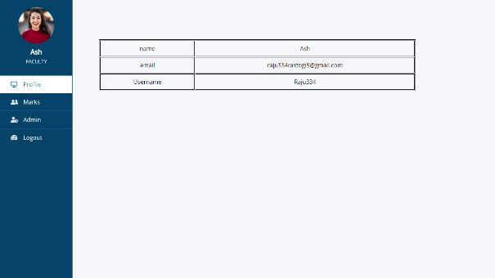](https://user-images.githubusercontent.com/131831457/260325557-a3a9237b-b610-4b74-9169-510e1ad40a8a.png)

[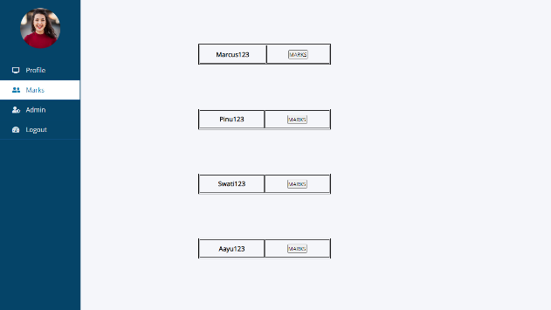](https://user-images.githubusercontent.com/131831457/260325558-320effda-7572-43d3-b766-9462810821d2.png)

[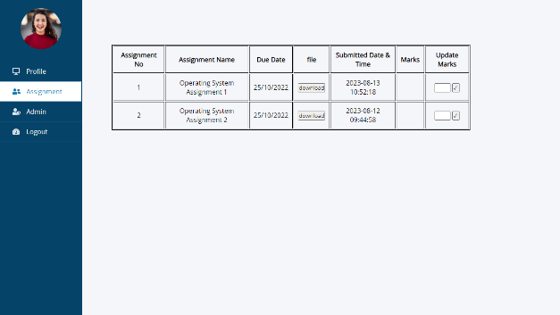](https://user-images.githubusercontent.com/131831457/260325563-d2cfa276-a55c-4cf0-9267-20f141939660.png)

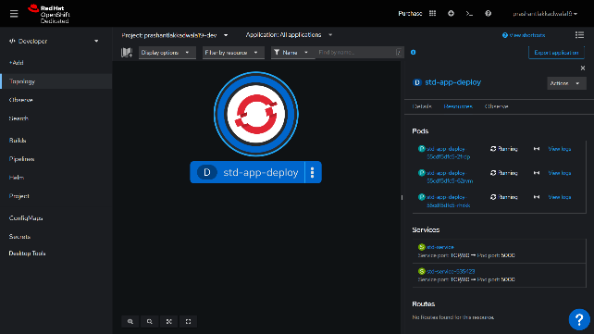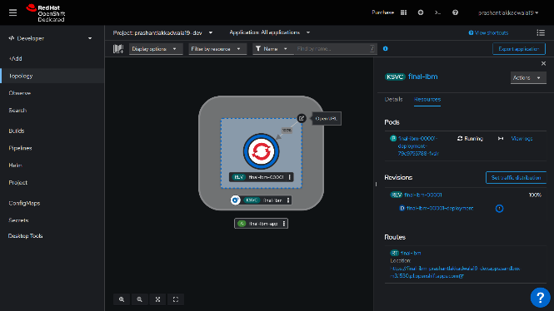[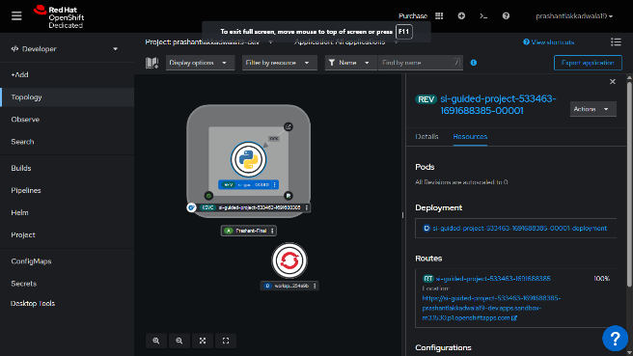](https://user-images.githubusercontent.com/131831457/261187539-d91ebb77-3b4e-4f4d-b9d5-722d385fcd15.png)[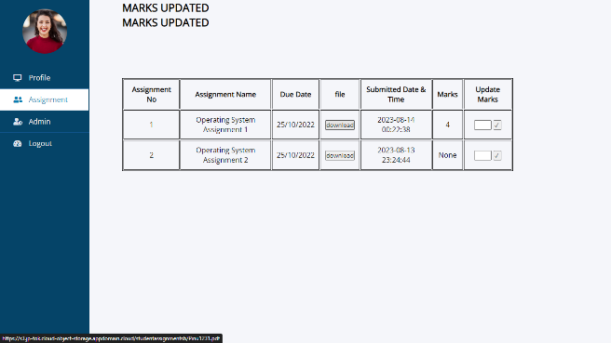](https://user-images.githubusercontent.com/131831457/260325574-4b1411cb-4179-4c44-914c-a4f31abf50f1.png)[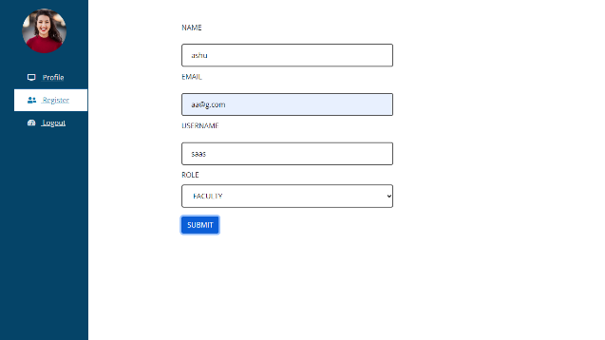](https://user-images.githubusercontent.com/131831457/260325590-e8dc9335-7a54-40aa-9d03-7535807a88c4.png)[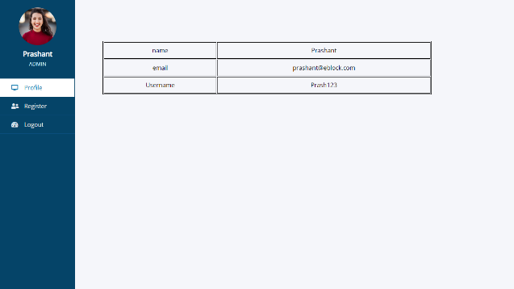](https://user-images.githubusercontent.com/131831457/260325584-d7473778-f01b-487f-90c1-518f5d9682ca.png)[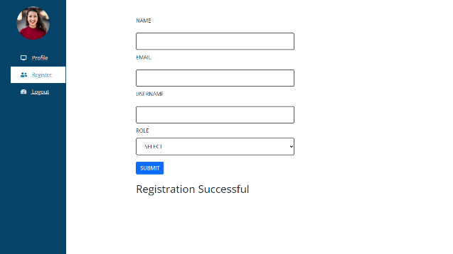](https://user-images.githubusercontent.com/131831457/260325602-7c2e50b4-55f0-42ff-9501-1d68640cf6c9.png)

# Advantages & Disadvantages

## ****Advantages of the Proposed Solution:****

The proposed Smart Assignment Website offers significant advantages. Automation streamlines assignment tasks—creation, submission, grading—saving time. Direct teacher-student communication fosters collaboration and timely feedback. Notifications keep students on track with due dates. Centralized assignment management eases administrative burdens. Secure file uploads ensure confidentiality. Immediate feedback aids learning. Remote learning support ensures continuity. A user-friendly interface suits diverse users. Reduced paper usage aligns with eco-friendliness. Data analytics potential aids educators' insights.

## ****Disadvantages of the Proposed Solution:****

While beneficial, the solution has considerations. Initial setup complexities might require technical expertise. Dependence on technology poses risks of disruptions. A learning curve for digital tools might affect some users. Data privacy concerns require robust safeguards. Automated grading's suitability for complex assignments is limited. Ongoing updates and costs for maintenance are necessary. Limited offline access and technology disparities might hinder usage. Resistance to change from traditional methods could arise.

# Applications

The Smart Assignment Website solution finds relevance across diverse educational contexts and scenarios, providing streamlined assignment management and enriched learning experiences.

In traditional school settings, the platform holds potential to revolutionize assignment processes. Teachers can efficiently create, distribute, and grade assignments, while students benefit from well-organized task management and timely notifications. Similarly, higher education institutions, including colleges and universities, can capitalize on the platform to manage assignments across various courses and departments, offering a centralized hub for students to submit assignments and receive feedback.

For institutions engaged in online learning or hybrid education, the platform ensures continuity in assignment management, transcending physical boundaries. It empowers educators to deliver assignments and feedback seamlessly regardless of geographical locations. In the domain of distance education, where students learn remotely, the platform facilitates efficient assignment management and evaluation, enriching the learning journey.

In professional development contexts, the solution lends itself as a tool to administer assignments and assessments, enhancing the learning process for participants. Likewise, training institutes offering specialized courses can utilize the platform for project assignments, progress tracking, and personalized feedback, enhancing the educational experience.

The applications extend to skill enhancement platforms, where users engage in self-improvement. By integrating the solution, these platforms offer interactive assignments and assessments within a cohesive learning environment. Continuing education programs also benefit from the streamlined assignment management the platform provides, catering to professionals pursuing further knowledge.

In language learning apps, the platform can be integrated to deliver interactive assignments and practical language assessments, enhancing language acquisition. Furthermore, research programs and workshops can leverage the platform for efficient assignment submissions, document sharing, and feedback, simplifying processes for participants.

In personalized contexts like tutoring and coaching, the platform assists tutors and coaching centres in assigning work, tracking progress, and offering personalized guidance. Additionally, specialized courses such as coding bootcamps can utilize the platform for coding assignments, automated evaluations, and comprehensive progress tracking.

# Conclusion

In culmination, the Smart Assignment Website project presents a comprehensive solution to address the challenges associated with traditional assignment management in educational settings. Through the integration of modern technologies, thoughtful design, and user-centric features, the project offers a platform that streamlines assignment creation, submission, grading, and communication. This endeavor has been driven by the overarching goal of enhancing the efficiency, collaboration, and learning experience for administrators, teachers, and students.

The literature survey highlighted existing shortcomings in assignment management processes, which often rely on manual workflows, leading to inefficiencies and communication gaps. The proposed solution, built upon Flask, IBM DB2, and IBM COS, sets out to bridge these gaps by introducing a role-based access system that empowers administrators, teachers, and students with tailored functionalities. Teachers can create assignments, grade submissions, and provide feedback efficiently, while students gain a centralized space for submitting assignments and receiving timely notifications about deadlines and updates.

Through experimental investigations, the project's viability and effectiveness were rigorously assessed. User testing and feedback provided insights into the platform's usability, while performance and security evaluations ensured its robustness. Compatibility and data integrity testing validated its functionality across devices and confirmed secure data handling. The investigations informed iterative refinements to create a well-rounded solution that meets the diverse needs of users.

The proposed solution holds significant advantages, including automation, enhanced communication, timely notifications, and streamlined assignment management. However, it also entails challenges such as technical complexities, learning curves, data privacy concerns, and potential resistance to change. These advantages and challenges, when considered collectively, contribute to a comprehensive understanding of the potential impact and limitations of the Smart Assignment Website project.

The applications of this solution span various educational domains, encompassing traditional schools, higher education, online learning, professional development, and specialized training. It holds the potential to revolutionize assignment management and improve learning experiences, catering to a wide array of users seeking efficient collaboration and effective learning outcomes.

In sum, the Smart Assignment Website project embodies innovation and responsiveness to the evolving educational landscape. Through the integration of technology and user-focused design, it addresses key challenges in assignment management, contributing to streamlined processes, enhanced communication, and ultimately, enriched educational experiences for all stakeholders involved.

# Future Scope

The Smart Assignment Website project lays a solid foundation for efficient assignment management and improved collaboration within educational environments. As technology continues to evolve, there are several avenues for future enhancements that can further elevate the platform's capabilities and impact.

One potential area for advancement lies in the integration of advanced artificial intelligence and machine learning techniques. These technologies can be harnessed to provide more sophisticated automated grading, taking into account nuanced evaluation criteria and subjective assessments. Additionally, natural language processing could enable more personalized feedback, enhancing the quality of the learning experience.

The platform's analytics capabilities can be expanded to provide educators with deeper insights into assignment performance trends and student engagement. By analyzing data related to assignment completion rates, submission timings, and student interactions, educators can tailor their teaching strategies more effectively and identify areas for improvement.

Collaboration features can be augmented to support group assignments and peer assessments. Enabling students to collaborate on assignments in real time and providing mechanisms for peer evaluation can promote teamwork and communication skills. Furthermore, expanding the platform's communication tools to include discussion forums or chat functionalities can foster a sense of community among students and educators.

As the educational landscape embraces diverse learning modalities, the platform can be adapted for use in virtual reality (VR) or augmented reality (AR) environments. This would enable students to engage with assignments in immersive ways, potentially enhancing their understanding and retention of complex concepts.

To address concerns about data privacy and security, continuous advancements in encryption techniques and user authentication mechanisms can be implemented. Additionally, seamless integration with single sign-on (SSO) solutions and multi-factor authentication (MFA) can enhance the platform's security posture.

As mobile devices become more prevalent in education, optimizing the platform for mobile responsiveness and developing dedicated mobile applications could extend its accessibility and convenience, allowing users to engage with assignments and notifications on the go.

# Appendix

## Source Code:

[GitHub - smartinternz02/SI-GuidedProject-533463-1691688385: Mentorship Program - Smart Assignment Engine](https://github.com/smartinternz02/SI-GuidedProject-533463-1691688385)